Day 3

Conclusion:

The higher noise, the less accurate the solution.

Each noise level has a different optimal- $α$.

Plot:

With $α$ = 0.01; $σ=0.01$

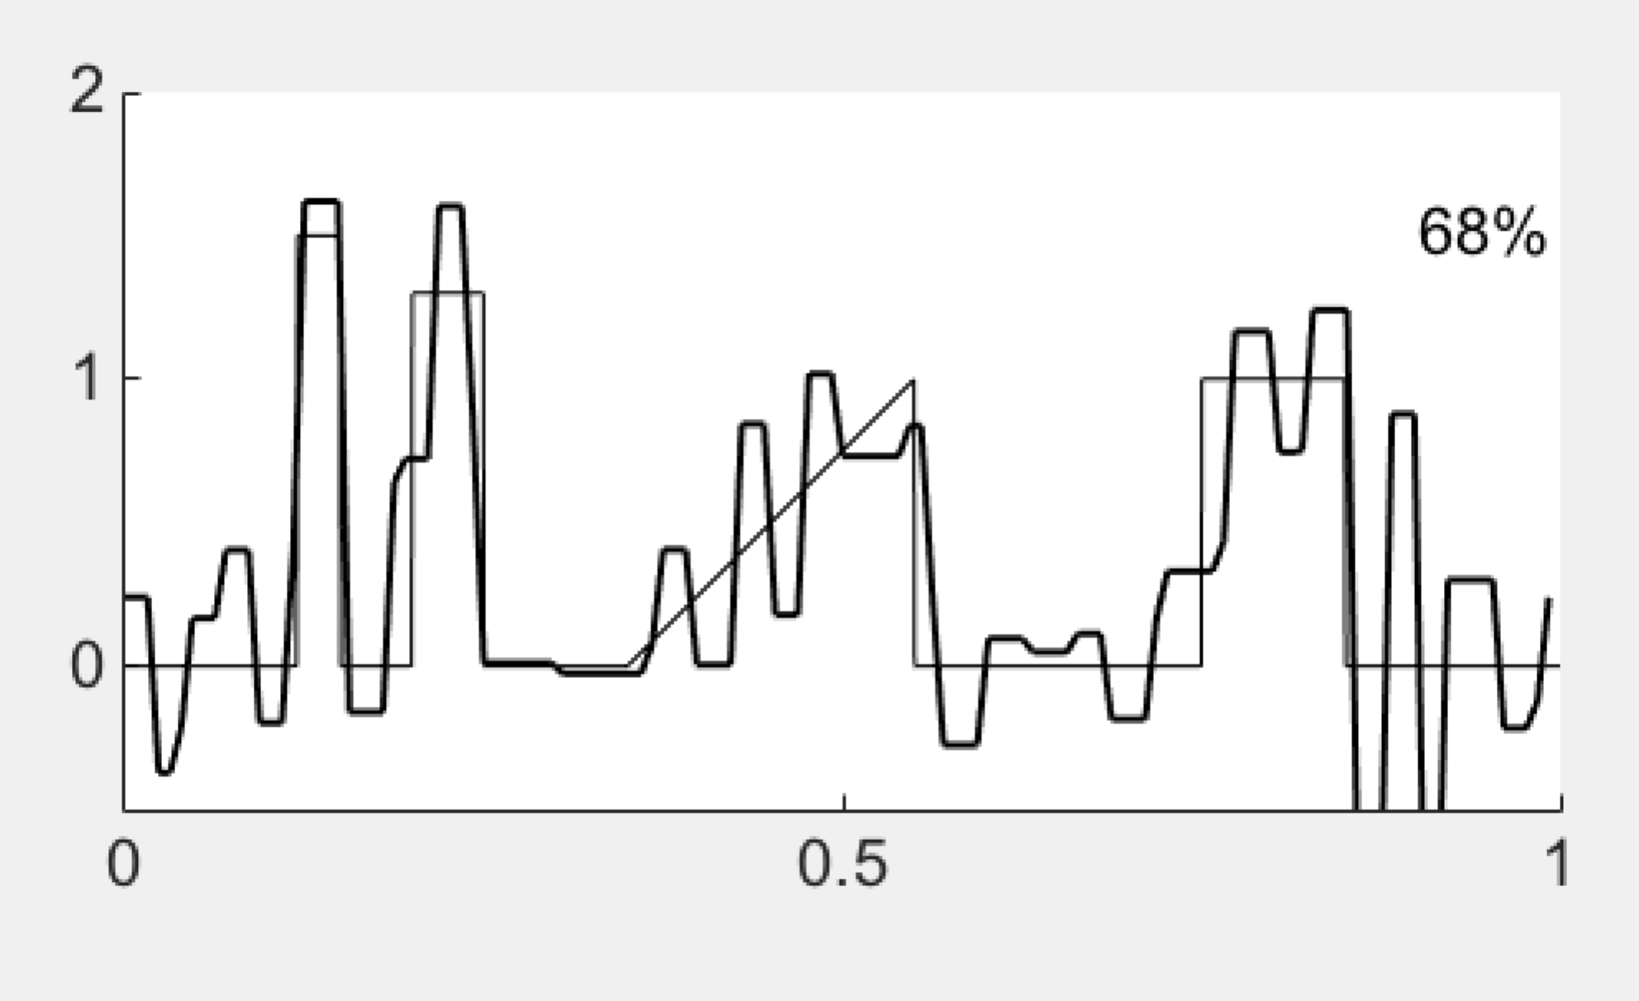

$σ=0.05$; $α=0.01$

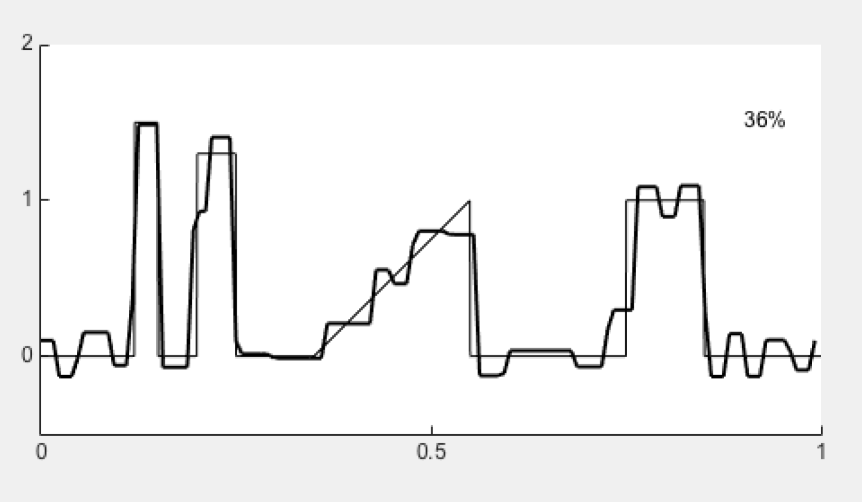

$σ=0.1$; $α=0.01$

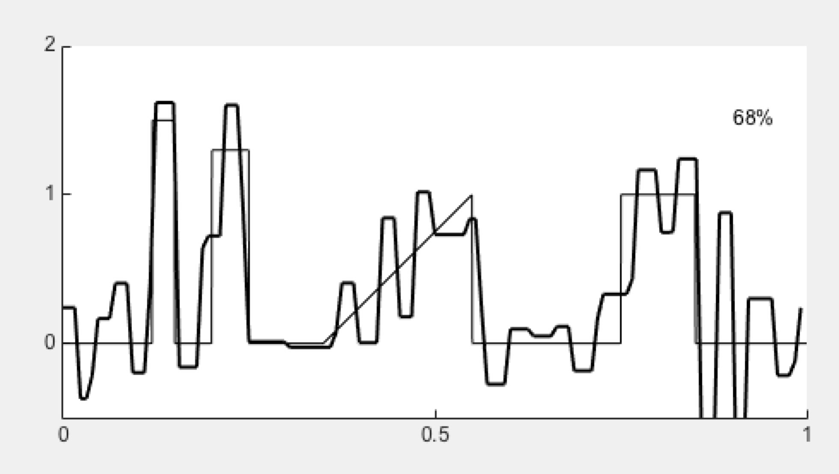

Relation of alpha and error, $σ=0.01$

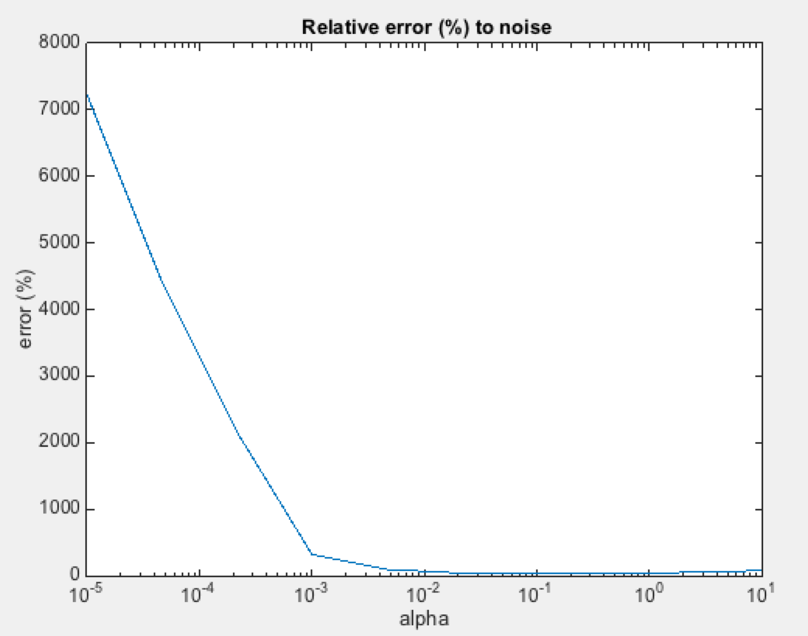

Optimal alpha is around 0.01